1)

A software application with the goal of predicting the rate of the fuel

-Needs a homepage with interactive buttons and directory

-Sign up with text boxes that convert text to information and stores it

-Login which means we need to access stored information, gives error if wrong info

-Client Profile Management after client registers they should login first to complete profile

-Fuel Quote Form with Pricing module with code for calculating cost given imputed information based on fuel

-Fuel Quote History is saved data

2)

We will be using the agile process specifically TDD mostly because it gives us the opportunity to clean our code with multiple test cases. Also it is modern and has proven to be effective.

3)

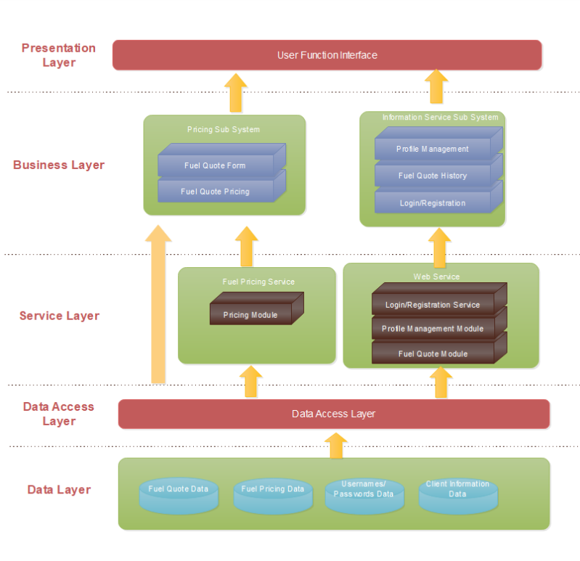

4.)

|  |  |  |
| --- | --- | --- |
| Group Member Name | What is your contribution? | Discussion Notes |
| Hugh Hoang | Question 1 and helped other ones |  |
| Julio Santos | Question 2 and helped other ones |  |
| Huan Huynh | Question 3 and helped other ones |  |